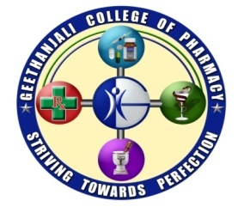 | GEETHANJALI COLLEGE OF PHARMACY  (APPROVED BY AICTE, PCI NEW DELHI, PERMANENTLY AFFILIATED TO JNTUH AND RECOGNIZED by DSIR-SIRO, UNDER SECTION 2(f), 12 (B) of UGC Act, 1956)  CHEERYAL (V), KEESARA (M), MEDCHAL DIST, TELANGANA, 501301 | 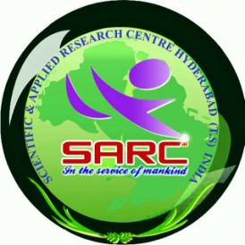

Dear Pharmacy Colleagues,

I am pleased to inform you that, we are going to conduct 10th TWO Days National Seminar “DRAVYAKA-2019” during 13^{h}& 14th November, 2019 with the theme “Rare Diseases - Orphan Drugs And Their Prevalence In Public” in association with Scientific & Applied Research Center, Hyderabad and Sponsored by Science and Engineering Research Board (SERB), India, at our Geethanjali College of Pharmacy, Cheeryal (V), Keesara (M), Medchal District, T.S. The main objective of the seminar is to create a common platform where teachers, students, research scholars, experts of academia, drug regulators and industry will interact and share the current trends in the field of pharmaceutical sciences, so that every participant will be enriched with the knowledge and also experience pharmaceutical climate.
I sincerely solicit your participation and also request you to encourage your students to submit abstracts of scientific papers and posters for the seminar.

We are happy to announce that, there is a NOMINAL REGISTRATION FEE Rs. 400/- for the participant.
Expecting your co-operation and participation,

Pharmacistly Yours

Prof.Dr. M.Ravi Kumar, M.Pharm., Ph.D., PDF (USA),
Principal,
Geethanjali College of Pharmacy
Cheeryal (V), Keesara (M), Medchal.District,
501 301 T.S.
Mobile: 9848842631

